Heal Rewilding Somerset
Micro moth report 2024
By
Jenny Vickers
Introduction
The following is a report on the micro moths found at Heal Somerset near Witham Friary for the year 2024.

The methods used for detection were visual search for leaf mines/early stages and adults, most of which were photographed and a selection taken home to rear through to aid identification. Early stages/leaf mines indicate the species of micro moth definitely using the food plants available on site and crucially, proof of breeding. There was a small amount of light trapping on a couple of occasions only. The work was undertaken all year round.

For this report, the targeted fields on the site covered were E1, S2 and N7. However, additional visits were made to E3, S1, S3, S8/9 and S13 to look for specific species on trees/herbaceous plants not found in the three main fields.

Species
The figure at the start of each species is based on the Checklist of the Lepidoptera of the British Isles by D Agassiz, S Beavan & R Heckford (2013). The species (in italics) are placed under their respective families and with the most up-to-date common names in brackets along with the foodplant used where applicable.

The following is the criteria for national status in Great Britain as found in The Review of the Status of Microlepidoptera in Britain by Tony Davis 2012.

pRDB 1 – Occurs in 5 or less 10km squares
pRDB 2 – Occurs in 6 – 10 10km squares
pRDB 3 – Occurs in 11 – 15 10km squares
pRDB K – Suspected, but not definitely known, to be in one of the above categories but not enough information available to say which.
Nationally Scarce A – Occurs in 16 – 30 10km squares
Nationally Scarce B – Occurs in 31 to 100 10km squares
Local – Occurs in 101 – 300 10km squares
Common – Occurs in more than 300 10km squares

MICROPTERIGIDAE
1.005 Micropterix calthella (Plain Pollen-moth) – adults feeding on Ranunculus sp
National status – common
Site notes – several adults found in field E1 only

NEPTICULIDAE
4.006 Stigmella sakhalinella (Glossy Birch Dot) – mine on Downy Birch (Betula pubescens)
National status – local
Site notes – one mine found on the only known Downy Birch on site in field S9

4.010 Stigmella microtheriella (Nut-tree Dot) – mine on Hazel (Corylus avellana)
National status – common
Site notes – several mines found in the fields surveyed

4.015 Stigmella anomalella (Rose Dot) – mine on Dog Rose (Rosa canina)
National status – common
Site notes – several mines found in the fields surveyed

4.018 Stigmella ulmivora (Barred Elm Dot) – mine on Wych Elm (Ulmus glabra)
National status – local
Site notes – one mine found in field N7

4.026 Stigmella oxyacanthella (Fruit-tree Dot) – mine on Hawthorn (Crataegus monogyna)
National status – common
Site notes – several mines found in fields E1 and S2

4.032 Stigmella floslactella (Speckled Hazel Dot) – mine on Hazel (Corylus avellana)
National status – common
Site notes – a few mines found in fields E1 and S13

4.035 Stigmella salicis cluster 1 sensu stricto (Sallow Dot) – mine on Goat Willow (Salix caprea) egg underside
National status – common
Site notes – several mines found in fields E1, S2 and S13

4.0351 Stigmella salicis cluster 6 (Un-named) – mine on Goat Willow (Salix caprea) egg upperside
National status – undetermined at present
Site notes – several mines found in field E1, S2, S9, S13 and N7

4.042 Stigmella plagicolella (Blue-shot Dot) - mine on Blackthorn (Prunus spinosa)
National status – common
Site notes – common mine in all fields surveyed

4.045 Stigmella aurella (Golden Dot) – mine on Bramble (Rubus fruticosus agg.)
National status – common
Site notes – common mine in all fields surveyed
Breeding notes – mine collected 13/03, adult emerged 03/05

4.054 Stigmella perpygmaeella (Least Hawthorn Dot) – mine on Hawthorn (Crataegus monogyna)
National status – common
Site notes – two mines found in field S2

4.058 Stigmella basiguttella (Shoulder-spot Dot) – mine on Oak (Quercus robur)
National status – common
Site notes – two mines found, one in field E1 and one in field E3

4.061 Stigmella atricapitella (Black-headed Dot) – mine on Oak (Quercus robur)
National status – common
Site notes – several mines found in fields E1, E3 and S2

4.063 Stigmella roborella (Oak Dot) – mine on Oak (Quercus robur)
National status – common
Site notes – two mines found, one in field E1 and one in field E3

4.075 Etainia louisella (Maple Seed Dot) – mine on Field Maple samara (Acer campestre)
National status – local
Site notes – 4 mines found, all in field E1
Breeding notes – mine collected 09/08, adult emerged 27/08

4.082 Ectoedemia intimella (White-spot Sallow Dot) – mine on Goat Willow (Salix caprea)
National status – local
Site notes – several mines found in fields E1, E3 and N7

4.085 Ectoedemia argyropeza (Aspen Dot) – mine on Aspen (Populus tremula)
National status – local
Site notes – two mines found in S13 where the food plant is on site

4.089 Ectoedemia albifasciella (White-banded Dot) – mine on Oak (Quercus robur)
National status – common
Site notes – several mines found in field E3

4.090 Ectoedemia subbimaculella (Broken-barred Oak Dot) – mine on Oak (Quercus robur)
National status – common
Site notes – many mines in field E1, E3, S2 and S13

4.091 Ectoedemia heringi (White-spot Dot) – mine on Oak (Quercus robur)
National status – local
Site notes – a few mines found in field S13

4.094 Ectoedemia angulifasciella (Angle-barred Rose Dot) – mine on Dog Rose (Rosa canina)
National status – common
Site notes – several mines found in field E1

4.095 Ectoedemia atricollis (Barred Fruit-tree Dot) – mine on Hawthorn (Crataegus monogyna)
National status – common
Site notes – a few mines found in fields E1, N7 and S2

4.097 Ectoedemia rubivora (Dewberry Dot) – mines on Bramble (Rubus fruticosus agg)
National status – nationally scarce B
Site notes – a few mines found in field E1

HELIOZELIDAE
6.001 Antispila metallella (Shining Dogwood Cutter) – mine on Dogwood (Cornus sanguinea) based on excised cut out in leaf
National status – local
Site notes – a few mines found in fields E1 and N7

6.002 Antispila petryi (Dogwood Cutter) – mine on Dogwood (Cornus sanguinea) based on excised cut out in leaf
National status – local
Site notes – one mine found in field E1

6.003 Heliozela sericiella (Oak Cutter) – mine on Oak (Quercus robur)
National status – local
Site notes – one mine found in field E1

6.004 Heliozela resplendella (Alder Cutter) – mine on Alder (Alnus glutinosa)
National status – local
Site notes – one mine found in field N7

ADELIDAE
7.006 Adela reaumurella (Green Longhorn) – males lekking
National status – common
Site notes – several males lekking on track in southern fields

7.007 Adela cuprella (Sallow Longhorn) – adults on Goat Willow (Salix caprea)
National status – local
Site notes – two adults, one in field S2 and one in S5

7.008 Adela croesella (Lesser Banded Longhorn) – adult
National status – local
Site notes – one adult in S2

7.010 Cauchas rufimitrella (Meadow Longhorn) – adults on Cuckoo Flower (Cardamine pratensis)
National status – common
Site notes – several adults on the food plant in fields S1 and S2

TISCHERIIDAE
10.001 Tischera ekebladella (Oak Blotch-miner) – mine on Oak (Quercus robur)
National status – common
Site notes – several mines found in fields E1, E3, S2 and S13

10.002 Tischera dodonaea (Small Oak Blotch-miner) – mine on Oak (Quercus robur)
National status – local
Site notes – one mine found in field E3

10.003 Coptotriche marginea (Bramble Blotch-miner) – mine on Bramble (Rubus fruticosus agg.)
National status – common
Site notes – common in all fields surveyed

PSYCHIDAE
11.002 Narycia duplicella (White-speckled Bagworm) – larval case on lichen
National status – common
Site notes – several larval cases found in fields S1 and S6
Breeding notes – larval case collected 18/03, adult emerged 02/06

11.008 Luffia lapidella (Ramshorn Bagworm) – larval case on lichen
National status – common
Site notes – a few larval cases found in field S6

TINEIDAE
12.006 Infurcitinea argentimaculella (Silver-barred Lichen Moth) – larval tube on lichen
National status – local
Site notes – one larval tube found in field S6

12.036 Monopis laevigella (Skin Moth) – larvae in pellets of Kestrel
National status – common
Site notes – several adults emerged from pellets collected in fields E3 and S6
Breeding notes – pellets collected 05/03, adults emerged 16/05

BUCCULATRICIDAE
14.010 Bucculatrix ulmella (Oak Tuft) – mine on Oak (Quercus robur)
National status – common
Site notes – several mines found in fields E3 and S2

GRACILLARIIDAE
15.004 Caloptilia elongella (Alder Stilt) – leaf roll on Alder (Alnus glutinosa)
National status – common
Site notes – several mines and leaf rolls found in field N7

15.008 Caloptilia alchimiella (Oak Stilt) – larva in leaf cone on Oak (Quercus robur)
National status – common
Site notes – one tenanted leaf cone found in field S9
Notes – pupa examined

15.010 Caloptilia stigmatella (Willow Stilt) – mine on Goat Willow (Salix caprea) and Aspen (Populus tremula)
National status – common
Site notes – several mines found in fields E1, N7, S2 and S13

15.019 Acrocercops brongniardella (Oak Cloud) – mine on Oak (Quercus robur)
National status – local
Site notes – one mine found in field S2
Breeding notes – mine collected 05/06, adult emerged 06/07

15.028 Parornix anglicella (Hawthorn Parornix) – mine on Hawthorn (Crataegus monogyna)
National status – common
Site notes – common in all fields surveyed

15.029 Parornix devoniella (Hazel Parornix) – mine on Hazel (Corylus avellana)
National status – common
Site notes – common in all fields surveyed

15.032 Parornix finitimella (Southern Blackthorn Parornix) – mine on Blackthorn (Prunus spinosa)
National status – common
Site notes – a few leaf folds found in fields S2 and S9
Notes – larva examined

15.033 Parornix torquillella (Blackthorn Parornix) – mine on Blackthorn (Prunus spinosa)
National status – common
Site notes – a few leaf folds found in fields E1 and S2
Notes – larva examined

15.034 Phyllonorycter harrisella (White Oak Leaf-miner) – mine on Oak (Quercus robur)
National status – common
Site notes – a few mines found in fields E3 and S13
Notes – cremaster examined

15.039 Phyllonorycter quercifoliella (Common Oak Leaf-miner) – mine on Oak (Quercus robur)
National status – common
Site notes – common in all fields surveyed
Breeding notes – mines collected between March and September, adults emerged between April and September

15.040 Phyllonorycter messaniella (Ilex Leaf-miner) – mine on Oak (Quercus robur)
National status – common
Site notes – several mines found in fields E1 and E3
Breeding notes – mine collected 09/08, adult emerged 19/08

15.043 Phyllonorycter oxyacanthae (Common Thorn Leaf-miner) – mine on Hawthorn (Crataegus monogyna)
National status – common
Site notes – common in all fields surveyed
Breeding notes - Leaf mine collected 03/08, adult emerged 14/08

15.049 Phyllonorycter spinicolella (Blackthorn Leaf-miner) – mine on Blackthorn (Prunus spinosa)
National status – common
Site notes – common in all fields surveyed

15.052 Phyllonorycter corylifoliella (Hawthorn Leaf-miner) – mine on Hawthorn (Crataegus monogyna)
National status – common
Site notes – common in fields E1, N7, S2 and S13

15.054 Phyllonorycter viminiella (Willow Leaf-miner) – mine on Goat Willow (Salix caprea)
National status – common
Site notes – adults emerged from mines in field S2 only
Breeding notes – leaf mines collected 17/07 and 15/08, adults emerged 27/07 and 25/08

15.056 Phyllonorycter salicicolella (Grey Willow Leaf-miner) – mine on (Salix cinerea)
National status – common
Site notes – adults emerged from mines in fields E3 and S13
Breeding notes – leaf mines collected 17/10 and 04/11, adults emerged 14/04/2025 and 18/04/2025

15.064 Phyllonorycter coryli (Nut Leaf Blister Moth) – mine on Hazel (Corylus avellana)
National status – common
Site notes – common in all fields surveyed

15.067 Phyllonorycter rajella (Common Alder Leaf-miner) – mine on Alder (Alnus glutinosa)
National status – common
Site notes – several mines found in field N7

15.071 Phyllonorycter nigrescentella (Vetch Leaf-miner) – mine on Bush Vetch (Vicia sepium)
National status – pRDB3
Site notes – several mines found in field E1

15.073 Phyllonorycter lautella (Small Oak Leaf-miner) – mine on Oak (Quercus robur)
National status – local
Site notes – a few mines found on young saplings in field S2

15.074 Phyllonorycter schreberella (Shining Elm Leaf-miner) – mine on Wych Elm (Ulmus glabra)
National status – common
Site notes – one mine found in field N7

15.075 Phyllonorycter ulmifoliella (Common Birch Leaf-miner) – mine on Downy Birch (Betula pubescens)
National status – common
Site notes – one mine found in field S9

15.078 Phyllonorycter tristrigella (Elm Leaf-miner) – mine on Wych Elm (Ulmus glabra)
National status – common
Site notes – several mines found in field N7

15.079 Phyllonorycter stettinensis (Lesser Alder Leaf-miner) – mine on Alder (Alnus glutinosa)
National status – common
Site notes – one mine found in field N7

15.080 Phyllonorycter froelichiella (Large Alder Leaf-miner) – mine on Alder (Alnus glutinosa)
National status – common
Site notes – three mines found in field N7

15.081 Phyllonorycter nicellii (Hazel Leaf-miner) – mine on Hazel (Corylus avellana)
National status – common
Site notes – a few mines found in field N7

15.082 Phyllonorycter klemannella (Shining Alder Leaf-miner) – mine on Alder (Alnus glutinosa)
National status – common
Site notes – one mine found in field N7

15.084 Phyllonorycter acerifoliella (Maple Leaf-miner) – mine on Field Maple (Acer campestre)
National status – common
Site notes – several mines found in fields E1, N7, S2 and S13

YPONOMEUTIDAE
16.002 Yponomeuta padella (Orchard Ermine) – larval web on Sloe (Prunus spinosa)
National status – common
Site notes – one larval web found in field S2

16.004 Yponomeuta cagnagella (Spindle Ermine) – larval web on Spindle (Euonymus europaeus)
National status – common
Site notes – several larval webs found in field N7

PLUTELLIDAE
18.001 Plutella xylostella (Diamond-back Moth) – adult in the field
National status – migrant
Site notes – one recorded in field S13

GLYPHIPTERIGIDAE
19.003 Glyphipterix fuscoviridella (Woodrush Moth) – adult
National status – common
Site notes – one adult recorded in field S1

19.007 Glyphipterix simpliciella (Cocks-foot Moth) – larva in stem of Cocks-foot Grass (Dactylis glomerata) and adults in the field
National status – common
Site notes – recorded in all fields surveyed

19.010 Digitivalva pulicariae (Fleabane Moth) – mines on Fleabane (Pulicaria dysenterica)
National status – local
Site notes – a few mines found in field E1
Breeding notes – mine collected 12/06, adult emerged 04/07

19.014 Acrolepia autumnitella (Speckled Bittersweet Moth) – mines on Bittersweet (Solanum dulcamara)
National status – common
Site notes – several mines found in fields E1, E3 and S8
Breeding notes – mine collected 15/08, adult emerged 15/09

LYONETIIDAE
21.002 Lyonetia prunifoliella (Blackthorn Blister Moth) – mine on Blackthorn (Prunus spinosa)
National status – pRDB1
Site notes – several mines found in fields E1 and S2
Breeding notes – mine collected 09/08, adult emerged 27/08

PRAYDIDAE
22.002 Prays fraxinella (Ash Bud Moth) – larva in wilted twig on Ash (Fraxinus excelsior)
National status – common
Site notes – one larva found in field S2

22.003 Prays ruficeps (Cryptic Ash Bud Moth) – adult to light trap
National status – local

BEDELLIIDAE
24.001 Bedellia somnulentella (Bindweed Sleeper) – mine on Bindweed (Convovulus sp)
National status – local
Site notes – one mine found in field N7

CHIMABACHIDAE
29.001 Diurnea fagella (Early Reveller) – adult
National status – common
Site notes – one recorded in field S6

PELEOPODIDAE
31.001 Carcina quercana (Oak Longhorn) – larvae and feeding signs on Oak (Quercus robur) and Alder (Alnus glutinosa)
National status – common
Site notes – commonly recorded in fields E1, E3, N7 and S2

DEPRESSARIIDAE
32.017 Agonopterix arenella (Brindled Buff) – larva from seedhead of Lesser Burdock (Arctium minus)
National status – common
Site notes – adult emerged from seed heads collected from field N7
Breeding notes - seeds collected, adult emerged 27/08

32.036 Depressaria radiella (Parsnip Moth) – larva on flowerhead of Hogweed (Heracleum sphondylium)
National status – common
Site notes – several larvae found in fields N7 and S2

32.039 Depressaria daucella (Water-dropwort Brown) – larva in flowerhead of Hemlock water-dropwort (Oenanthe crocata)
National status – common
Site notes – several larvae found in fields E1 and S2
Breeding notes – larva collected 31/05, adult emerged 06/07

GELECHIIDAE
35.011 Anacampsis populella (Poplar Roller) – larva in leaf roll on Oak (Quercus robur). Note: first time noted in Britain as using this foodplant rather than Poplars or Willow.
National status – common
Site notes – one leaf roll found in field S2
Breeding notes – leaf roll collected 21/05, adult emerged 24/06

35.109 Scrobipalpa acuminatella (Common Thistle Miner) – mine on Creeping Thistle (Cirsium arvense)
National status – common
Site notes – several mines found in fields E1, E3 and S2

35.150 Carpatolechia notatella (Willow Grey) – spun leaves on Grey Willow (Salix cinerea)
National status – local
Site notes – one spinning found in field N7
Breeding notes – leaf spinning collected 03.10.24, adult emerged 04.05.2025

COLEOPHORIDAE
37.006 Coleophora gryphipennella (Rose Case-bearer) – larval case on Dog Rose (Rosa canina)
National status – common
Site notes – two larval cases found in field E1

37.007 Coleophora flavipennella (Yellow Oak Case-bearer) – larval case on bud of Oak (Quercus robur)
National status – common
Site notes – one larval case found in field S2

37.015 Coleophora serratella (Common Case-bearer) – larval case on Downy Birch (Betula pubescens)
National status – common
Site notes – one larval case found in field S9

37.022 Coleophora lusciniaepennella (Willow Case-bearer) – larval case on Goat Willow (Salix caprea)
National status – common
Site notes – one larval case found in field S13

37.032 Coleophora albitarsella (White-legged Case-bearer) – larval case on Ground Ivy (Glechoma hederacea)
National status – local
Site notes – one larval case found in field S2

37.038 Coleophora lineolea (Woundwort Case-bearer) – larval case on Hedge Woundwort (Stachys sylvatica)
National status – local
Site notes – one larval case found in field N7

37.049 Coleophora anatinpennella (Pistol Case-bearer) – larval case on Blackthorn (Prunus spinosa)
National status – local
Site notes – a few larval cases found in fields E1, N7 and S2

37.069 Colephora caespititiella (Buff Rush Case-bearer) – larval case on Soft Rush (Juncus effusus)
National status – common
Site notes – one larval case found in field S2

37.073 Coleophora alticolella (Common Rush Case-bearer) – larval case on Rush (Juncus sp)
National status – common
Site notes – one larva confirmed from a case found in N7
Notes – larva examined

ELACHISTIDAE
38.037 Elachista canapennella (Common Grass-miner) – adult to light trap
National status – common

MOMPHIDAE
40.010 Mompha epilobiella (Buff Mompha) – larval spinning on Great Willowherb (Epilobium hirsutum)
National status – common
Site notes – several larvae found in fields E1 and S2

40.008 Mompha subbistrigella (Garden Mompha) – larval feeding signs on seeds of Great Willowherb (Epilobium hirsutum)
National status – common
Site notes – one feeding sign found in field S2

40.015 Mompha raschkiella (Fireweed Mompa) – mine on Rosebay Willowherb (Chamerion angustifolium)
National status – common
Site notes – a few mines found in field E3

BLASTOBASIDAE
41.003 Blastobasis lacticolella (Large Pale Masoner) – larva in seedhead of Lesser Burdock (Arctium minus) and also in fruits of Sloe (Prunus spinosa)
National status – common
Site notes – one larva in Burdock seed heads from field N7, one from fruits in field E1
Breeding notes – seedheads collected Oct 2023, adult emerged 18/06/2024

EPERMENIIDAE
47.005 Epermenia chaerophyllella (Common Ridge-back) – larvae on Hogweed (Heracleum sphondylium)
National status – common
Site notes – found in field E1

CHOREUTIDAE
48.001 Anthophila fabriciana (Nettle-tap Moth) – adults in the field
National status – common
Site notes – adults recorded in field E1, N7, S2 and S9

TORTRICIDAE
49.015 Archips xylosteana (Variegated Golden Tortrix) – larva in leaf roll on Oak (Quercus robur)
National status – common
Site notes – leaf rolls found in fields E1 and S2
Breeding notes – leaf rolls collected 15/05 and 12/06, adults emerged 15/06 and 18/06

49.031 Zelotherses paleana (Timothy Tortrix) – larva on Ribwort Plantain (Plantago lanceolata)
National status – common
Site notes – one larva found in field S1

49.037 Clepsis spectrana (Cyclamen Tortrix) – adult to light trap
National status - common

49.039 Epiphyas postvittana (Light Brown Apple Moth) – larva in leaf spinning on Dock (Rumex sp)
National status – common
Site notes – larva found in field S6
Breeding notes – leaf spinning collected 13/07, adult emerged 06/08

49.044 Tortricodes alternella (Spring Harbinger) – larva in spinning on Oak (Quercus robur)
National status – common
Site notes – leaf spinning found in field S1
Breeding notes – leaf spinning collected 09/05, adult emerged 24/02/2025

49.139 Cochylis atricapitana (Black-fronted Straw) – adult to light trap
National status - common

49.144 Eudemis profundana (Oak Marble) – larva in leaf spinning on Oak (Quercus robur)
National status – common
Site notes – leaf spinning found in field S2
Breeding notes – leaf spinning collected 21/05, adult emerged 30/06

49.154 Orthotaenia undulana (Dusky Marble) – larva in leaf spinning on Hawthorn (Crataegus monogyna)
National status – common
Site notes – larvae found in field N7 and S2
Breeding notes – leaf spinning collected 20/05, adult emerged 15/06

49.156 Hedya nubiferana (Marbled Orchard Tortrix) - adult
National status – common
Site notes – recorded in field E1

49.157 Hedya pruniana (Plum Tortrix) – larva in leaf spinning of Sloe (Prunus spinosa)
National status – common
Site notes – larvae found in field S2, adult recorded in field E1
Breeding notes – leaf spinning collected 21/05, adult emerged 15/06

49.166 Celypha lacunana (Common Marble) – adults in the field and also larvae on Great Willowherb (Epilobium hirsutum) and Sloe (Prunus spinosa)
National status – common
Site notes – larva found in field S2, adults common throughout the site
Breeding notes – leaf spinning collected 21/06, adult emerged 11/07

49.234 Epiniotia abbreviana (Brown Elm Tortrix) – feeding signs on Wych Elm (Ulmus glabra)
National status – common
Site notes – larval feeding signs found in field N7

49.240 Epinotia immundana (Birch Tortrix) – larva in catkin Alder (Alnus glutinosa)
National status – common
Site notes – larva found in field N7
Breeding notes – larva collected 26/01, adult emerged 13/08

49.248 Epinotia tenerana (Nut Bud Moth) – larvae in catkin of Alder (Alnus glutinosa) and Hazel (Corylus avellana)
National status – common
Site notes – larvae found in field N7

49.279 Gypsonoma dealbana (Common Cloaked Tortrix) – frass covered silk tube on Oak (Quercus robur), Goat Willow (Salix caprea) and Field Maple (Acer campestre)
National status – common
Site notes – common in all fields surveyed
Breeding notes – mines collected 21/05 and 05/06, adults emerged 24/06, 27/06, and 22/06

PYRALIDAE
62.048 Euzophera pinguis (Ash-bark Knot-horn) – adult to light trap
National status - common

CRAMBIDAE
63.020 Anania perlucidalis (Marsh Pearl) – adult to light trap
National status – common

63.038 Pleuroptya ruralis (Mother of Pearl) – leaf roll on Nettle (Urtica dioica)
National status – common
Site notes – larva found in field S2

63.072 Eudonia delunella (Pied Grey) – adult to light trap
National status – local

63.080 Chrysoteuchia culmella (Garden Grass-moth) – adults in the field and to light trap
National status – common
Site notes – common throughout the site

63.088 Crambus perlella (Satin Grass-moth) – adult to light trap
National status - common

63.089 Agriphila tristella (Common Grass-moth) – adults in the field and to light trap
National status – common
Site notes – noted throughout the site

63.092 Agriphila selasella (Pale-streaked Grass-moth) – adults in the field and to light trap
National status – local
Site notes – one recorded in field E1

63.093 Agriphila straminella (Straw Grass-moth) – adults in the field and to light trap
National status – Common
Site notes – common throughout the site

63.116 Cataclysta lemnata (Small China-mark) – adult to light trap
National status – common

For interest, some photos of some of the species found on site in 2024.

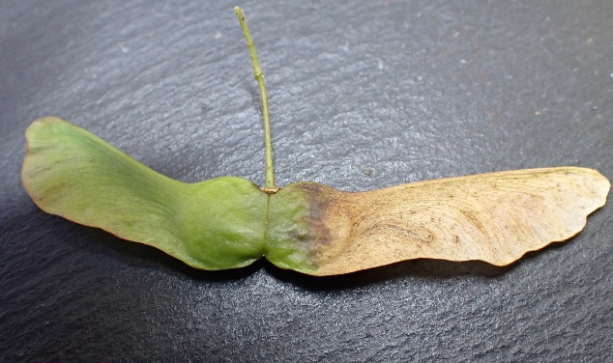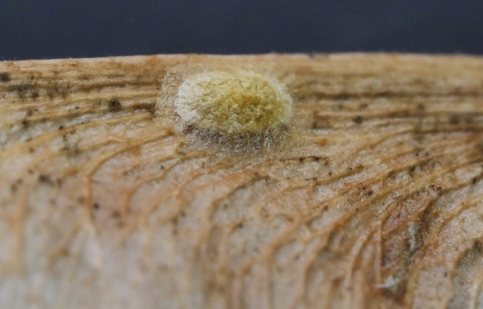
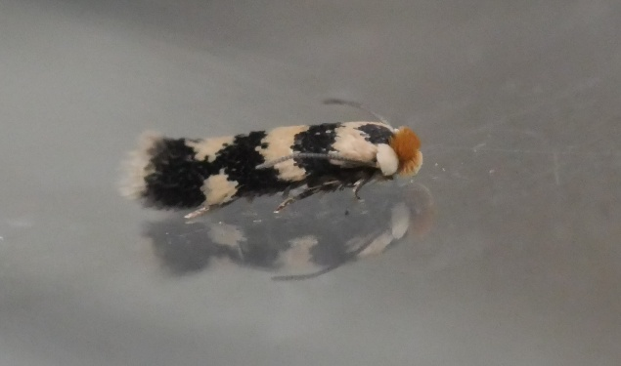
Etainia louisella (Maple Seed Dot), mine on Field Maple seed, cocoon and adult 3.5mm

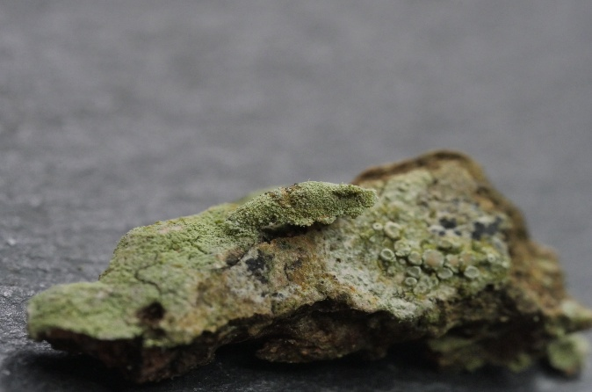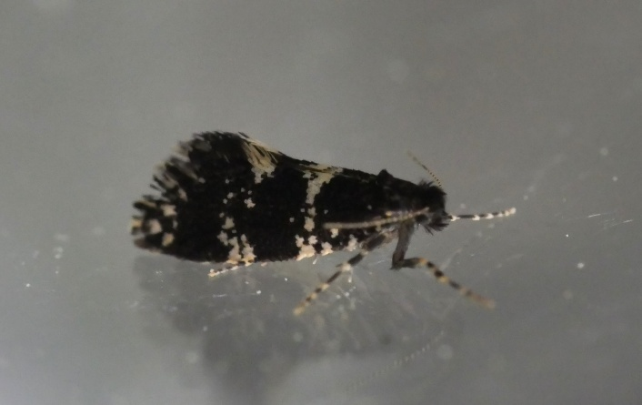
Narycia duplicella (White-speckled Bagworm) larval case on lichen and adult 6mm

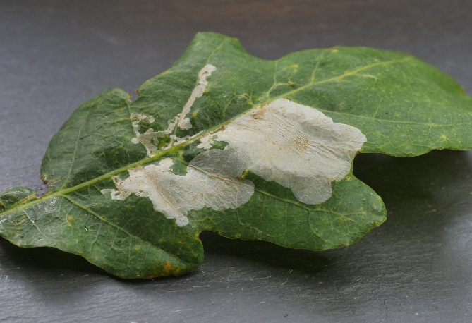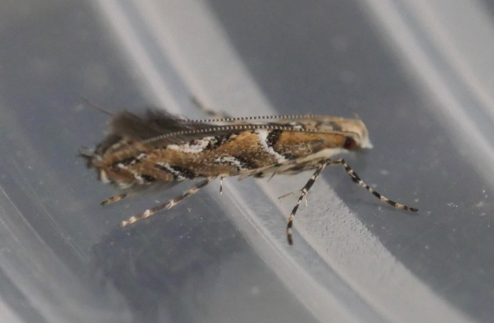
Acrocercops brongniardella (Oak Cloud) mine on Oak and adult 4.5mm

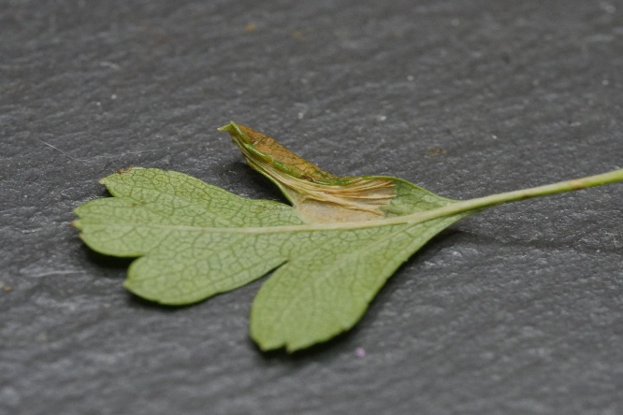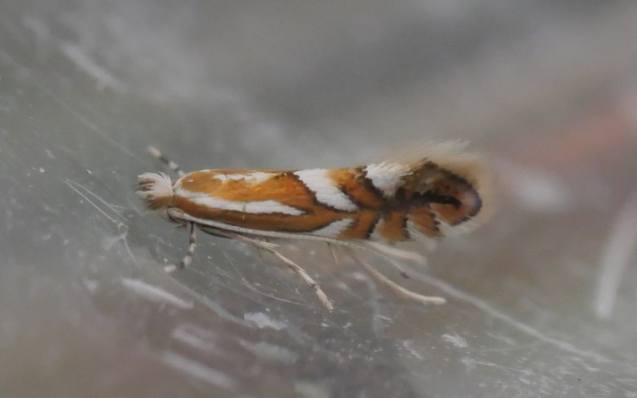
Phyllonorycter oxyacanthae (Common Thorn Leaf-miner) mine on Hawthorn and adult 4mm

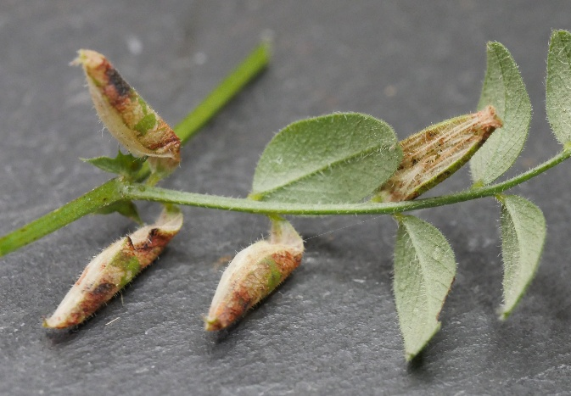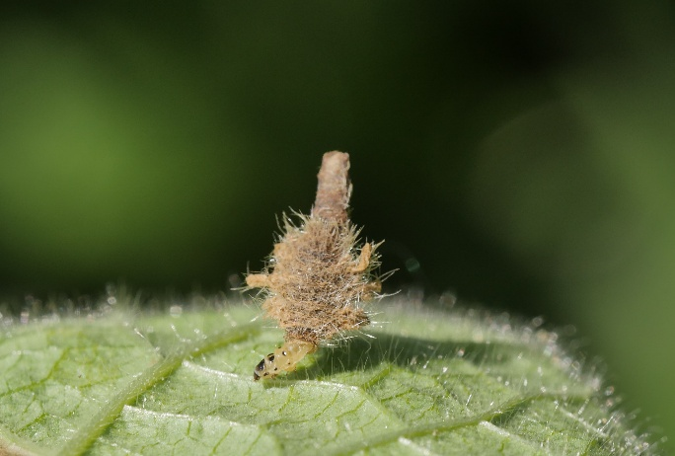
Phyllonorycter nigrescentella (Vetch Leaf-miner) Colephora lineolea (Woundwort Case-bearer)
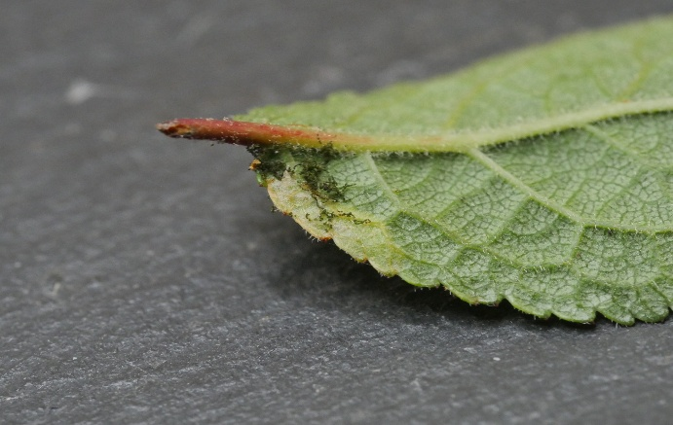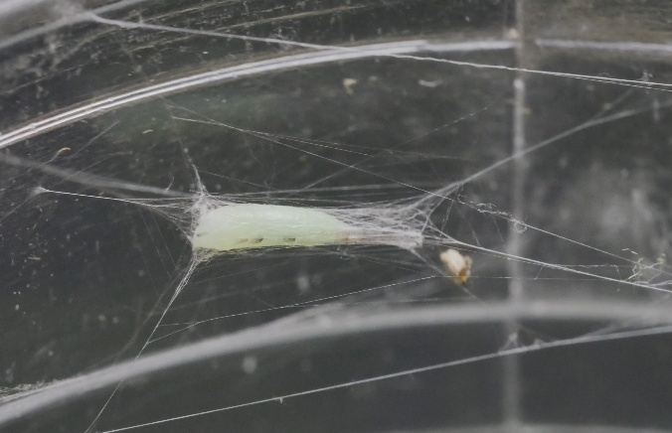
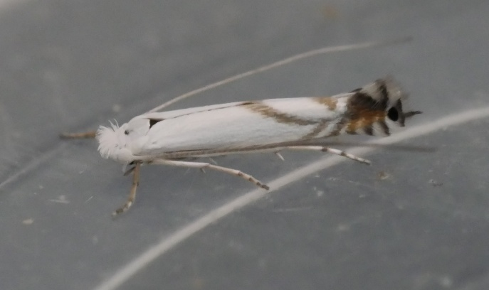
Lyonetia prunifoliella (Blackthorn Blister Moth) mine on Blackthorn, cocoon and adult 4.5mm

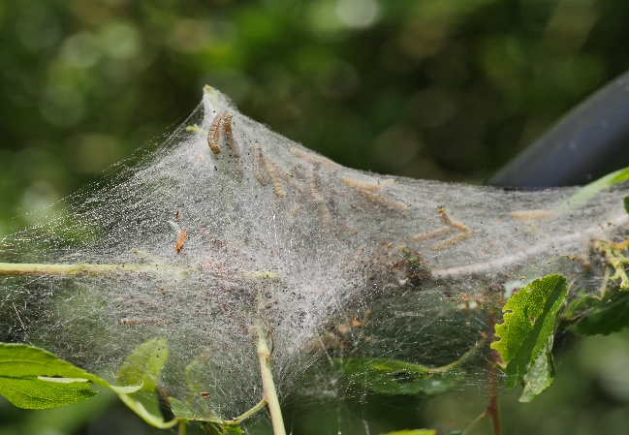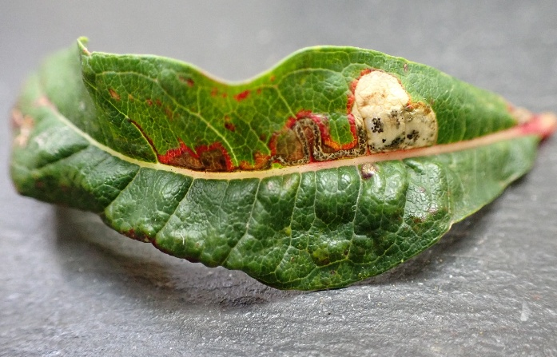
Yponomeuta padella(Orchard Ermine) Mompha raschkiella (Fireweed Mompha)

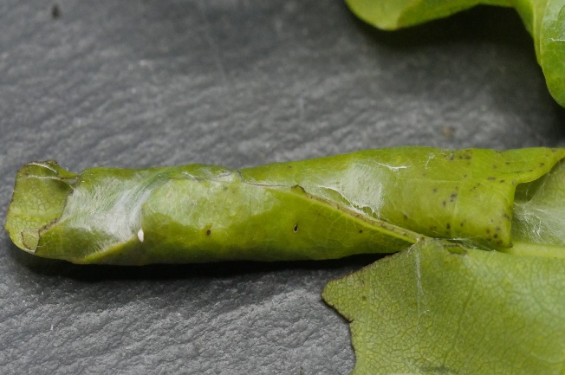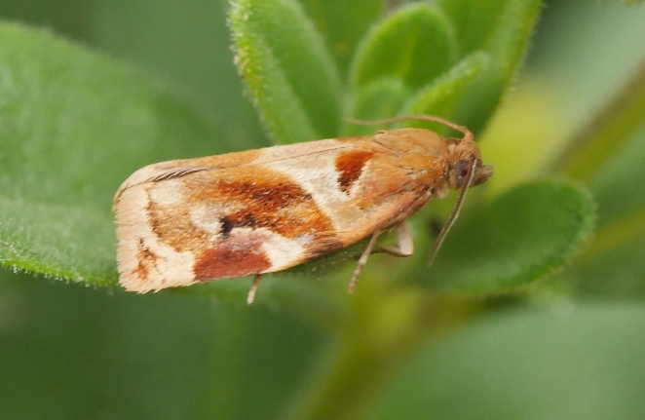
Archips xylosteana (Variegated Golden Tortrix) leaf roll on Oak and adult 10mm

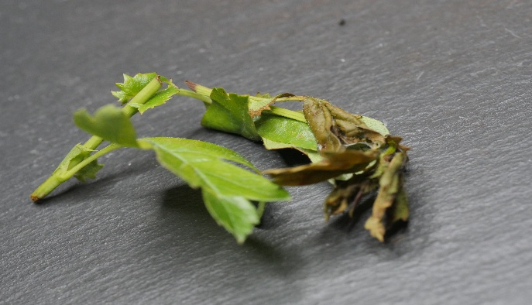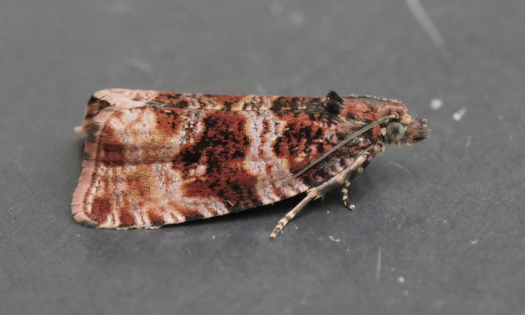
Orthotaenia undulana (Dusky Marble) leaf spinning on Hawthorn and adult 8mm

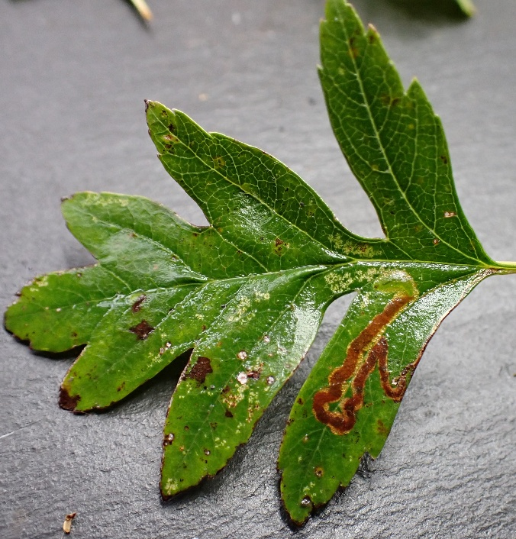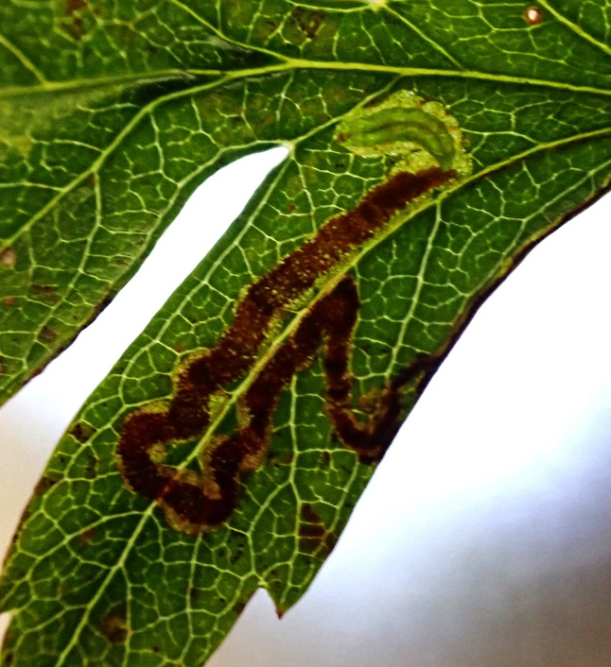
Stigmella oxyacanthella (Fruit-tree Dot) mine on Hawthorn, red frass and green larva

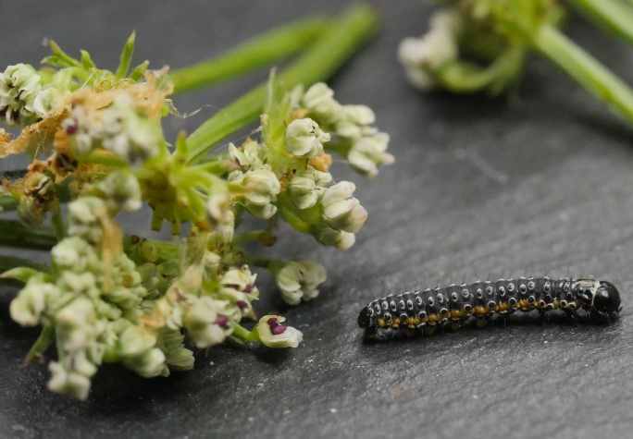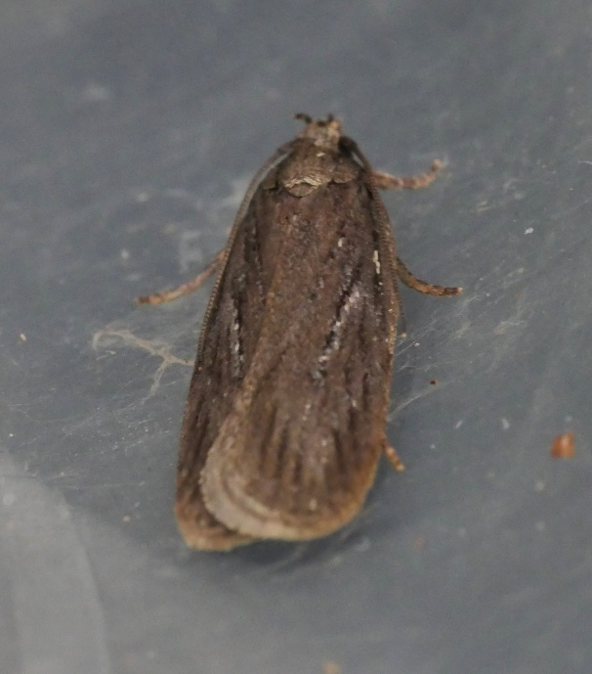
Depressaria daucella (Water Drop-wort Brown) larva from Hogweed flowers and adult 10mm

Notes on Nationally scarce and Red Databook species

Naturally, the majority of the 128 micro-moths encountered in this survey are quite
common and widespread in Somerset. However, 27 moths were found that
have a more restricted, local distribution and the following are particularly
noteworthy:

4.097 Ectoedemia rubivora - Nationally scarce B - Astonishingly local for a miner on brambles. In Somerset most records of this species come from a small area between Midsomer Norton and Shepton Mallet, where it is very irregular in occurrence, present in numbers on sites one year yet absent the next. It prefers damp shady locations. I’ve found it in small numbers on the Heal site two years running. Distribution map for Somerset Ectoedemia rubivora | Somerset Moths

15.071 Phyllonorycter nigrescentella - pRDB3 - Recently Somerset seems to have become a stronghold for this species. A very local species in the South-west and South-east of England but commoner in the north of England and Ireland. The mines are often found amongst tall vegetation under hedgerows rather than out in the open. Distribution map for Somerset Phyllonorycter nigrescentella | Somerset Moths

21.002 Lyonetia prunifoliella – pRDB1 - Formerly locally resident in parts of southern and central England, this moth seemed to have died out as a British species, and had not been reliably encountered since around 1900. The first recent record appears to be in 2007, since when it has been encountered with increasing frequency in a number of counties including Dorset, Norfolk and on the Isle of Wight, Hampshire. I found it in very small numbers in just one field on the Heal site in 2023. In 2024 I found more mines in two of the fields surveyed. This species prefers young Blackthorn saplings which are found in abundance on site now that the hedges are not flailed. Distribution map for Somerset Lyonetia prunifoliella | Somerset Moths

Sources of information
Books:
STERLING, P, PARSONS, M, & LEWINGTON, R. (2023). Field Guide to the Micro Moths of Great Britain and Ireland. British Wildlife Publishing, Gillingham.
MANLEY, C (2015) British Moths (Second edition) A Photographic Guide to the Moths of Britain and Ireland. Bloomsbury
EMMET, A M (reprint 2017). A Field Guide to the Smaller British Lepidoptera. The British Entomological and Natural History Society (revised by JR Langmaid, SM Palmer and MR Young)
SMART, B. (2017) Micro-moth Field Tips. A guide to finding the early stages in Lancashire and Cheshire. Lancashire & Cheshire Fauna Society
SMART, B. (2021) Micro-moth Field Tips. A guide to finding the early stages in Lancashire and Cheshire. Lancashire & Cheshire Fauna Society

Websites:
British Leaf miner website: www.leafmines.co.uk
UK Moths website: www.ukmoths.org.uk
Somerset Moth Group website: www.somersetmothgroup.org.uk
Butterfly Conservation website: http://www.mothscount.org/
Butterfly Conservation The Review of the Status of Microlepidoptera in Britain by Tony Davis 2012.
The Leaf and Stem Mines of British Flies and other Insects: http://www.ukflymines.co.uk/index.php
Eggs, Larvae, Pupae and Adult Butterflies and Moths: http://ukleps.org/
Plant Parasites of Europe: https://bladmineerders.nl/
Lepiforum: www.lepiforum.de

Acknowledgements
I would like to thank the team at Heal Rewilding for permission to undertake survey work on site. Particularly Jan Stannard and Daniel Hill for their help and enthusiasm.
For help with identification, I’d like to thank Paul Wilkins, Mike Bailey and Rob Edmunds

